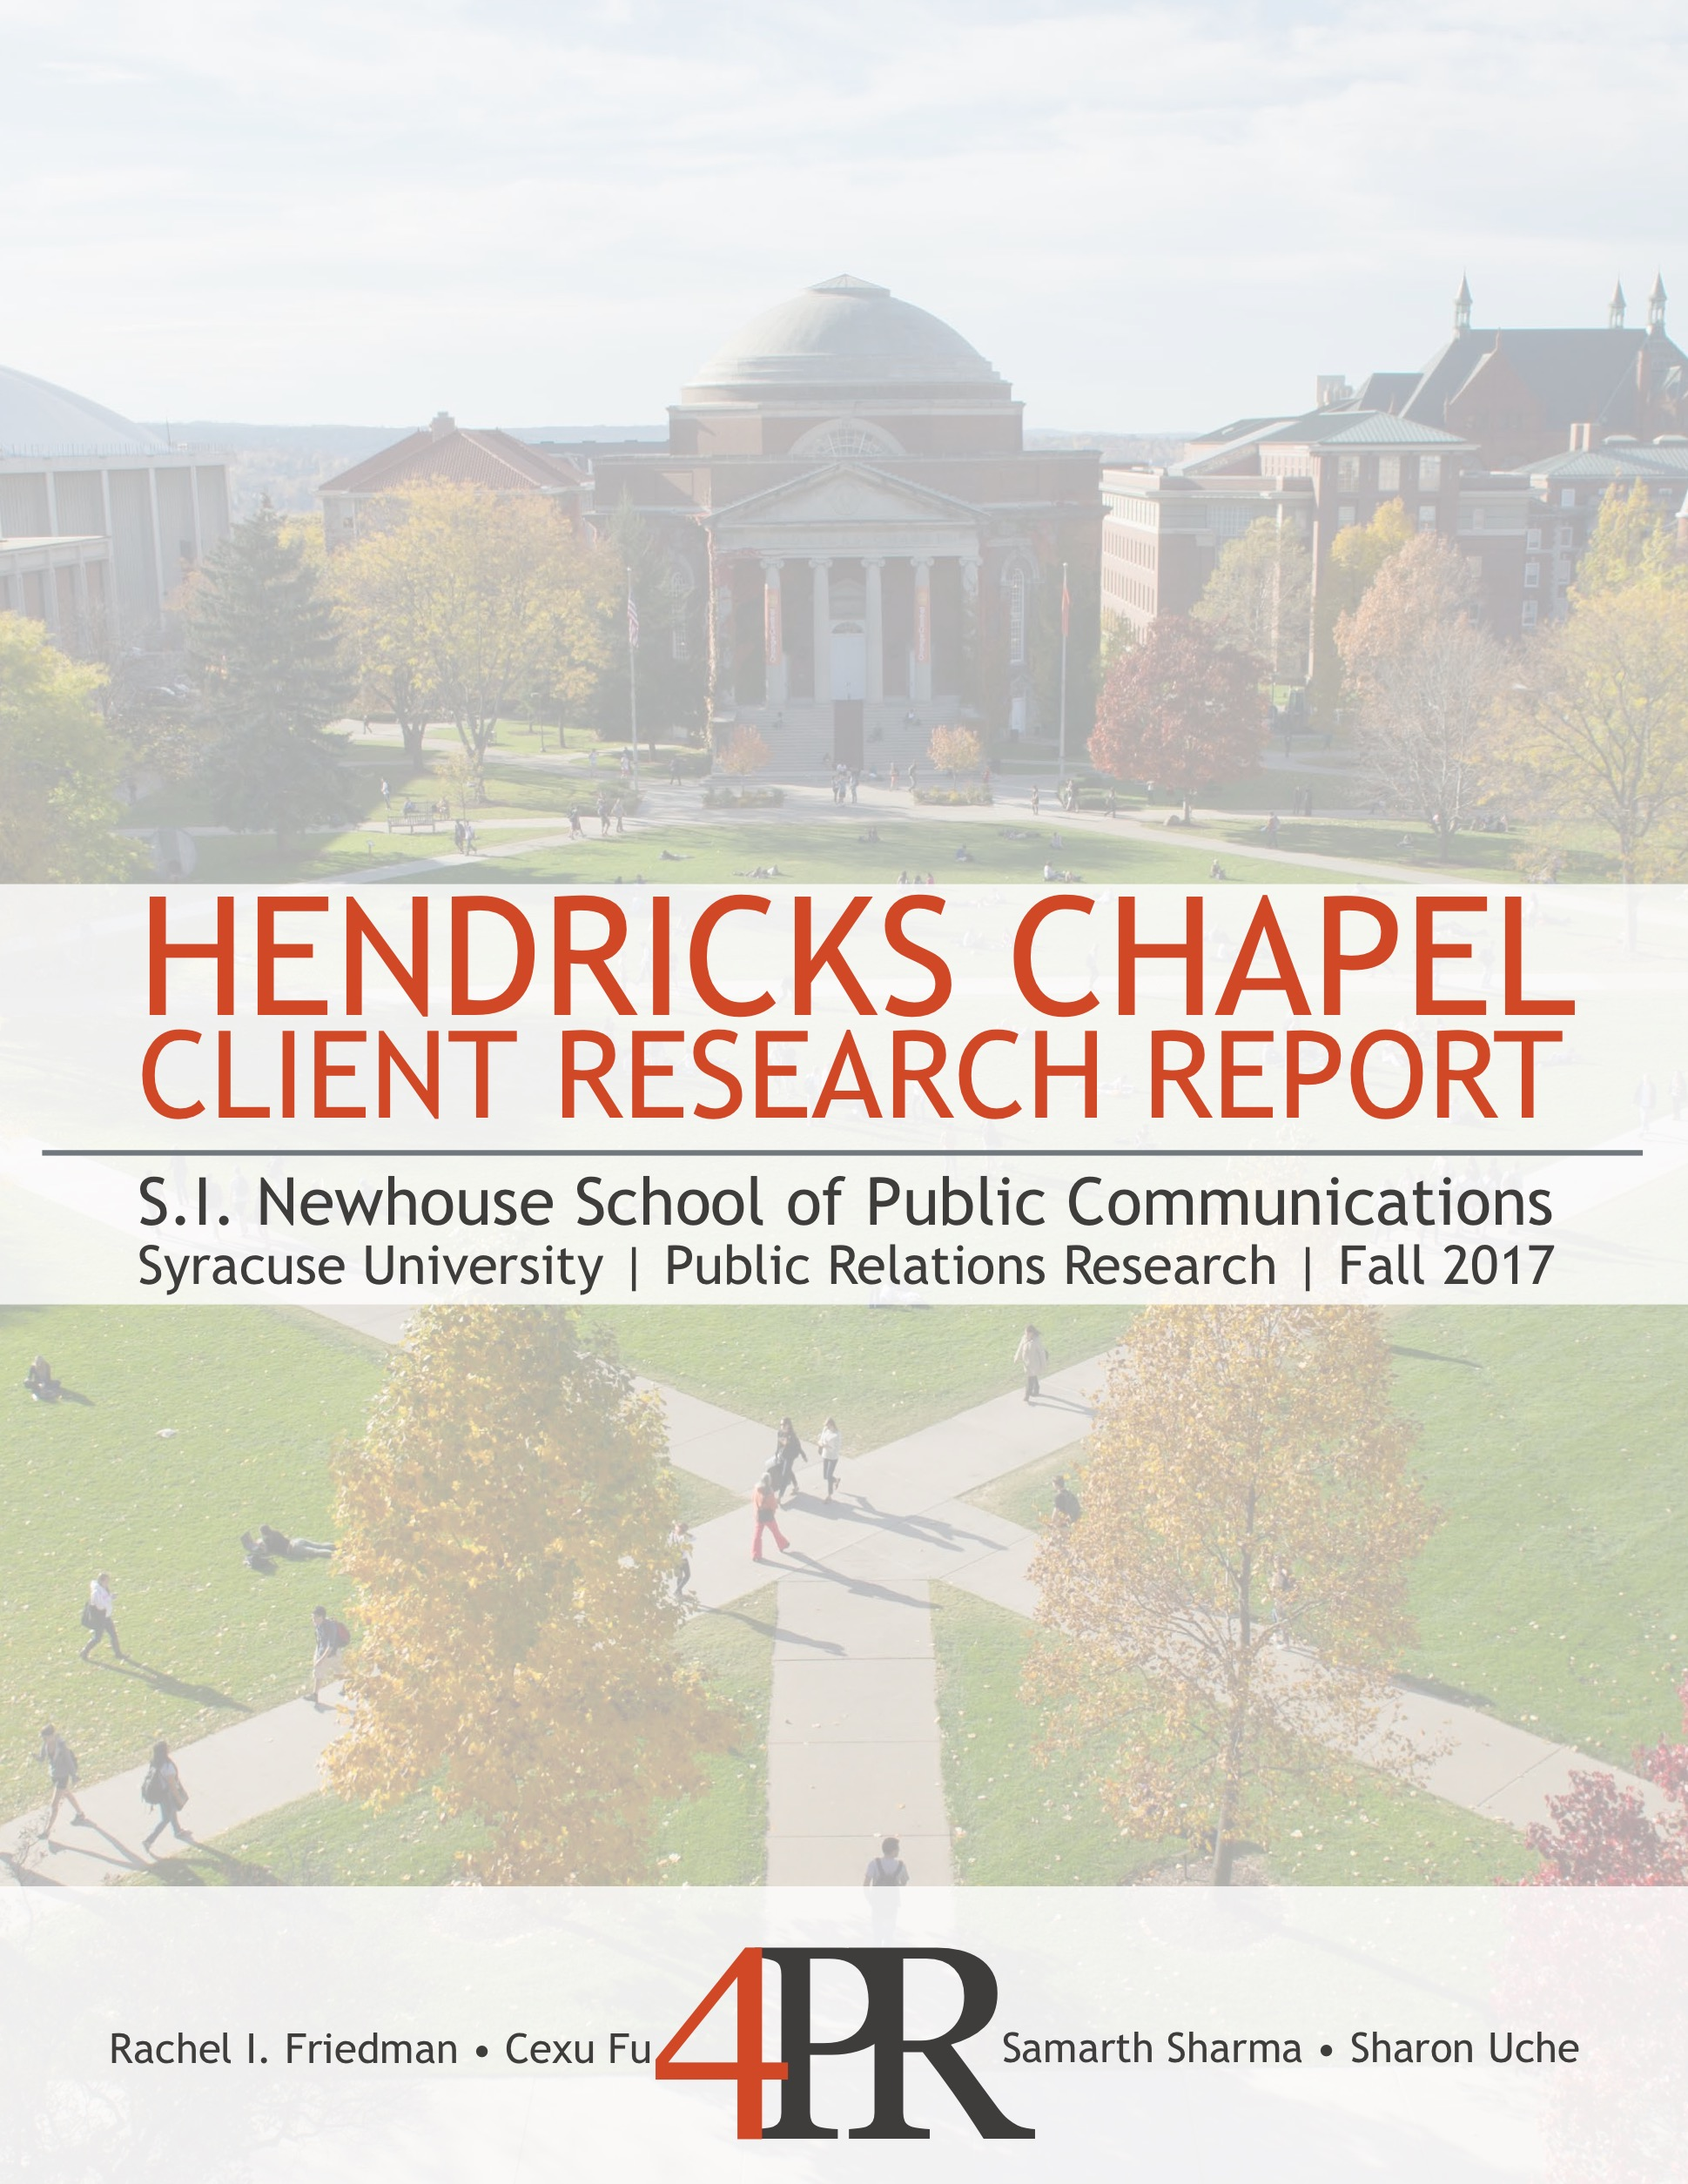

Table of Contents

Executive Summary 3

Situation Analysis 4

SWOT Analysis 6

Analyzing the Key Publics 9

Sample Key Publics 11

Research Objectives 14

Research Methodology 14

Research Results and Analysis 17

Focus Group Results and Analysis 31

Recommendations 32

References 36

Appendix 38

Executive Summary

Hendricks Chapel is located at the heart of Syracuse University. The chapel is a center that welcomes students, alumni, friends and community members of the Syracuse are coming from all walks of life including different faiths and beliefs. The chapel offers weekly programming, such as religious services and meditation sessions to enhance the students and communities experience with a spiritual center. Additionally, the chapel hosts special ceremonies, lectures and weddings. Hendricks Chapel is led by The Rev. Brian E. Konkol, Ph.D., and his team comprised of chaplaincies, staff and student volunteers.

4PR conducted research to determine how Hendricks Chapel could become more visible on Syracuse University’s campus and to the local community. By using research tools including an online survey, a focus group and social listening tools, the team was able to gain insight on how Hendricks Chapel can target their key audience’s. With this information, we are able to make recommendations as to how Hendricks Chapel can increase their visibility.

Throughout the research process, we found that Hendricks Chapel has an overall neutral view from their target audience. In order to change this sentiment to a positive one, Hendricks Chapel must better utilize social media platforms and blogs, increase their engagement with students, and have clear programming.

Situation Analysis

Public Relations Situation

Hendricks Chapel is at the heart of Syracuse University, with the overarching goal of bringing a community together. Whether it be a community of mutual faith or wanting a place to express themselves freely, students and community members have a space within Hendricks Chapel to make the most of their spiritual opportunities on campus. Based on the team meeting with Brian, it is evident that the Syracuse University community does not utilize all the services Hendricks Chapel offers, mainly because of the lack of visibility (Client Meeting, 2017). Additionally, Hendricks Chapel does not have a clear-cut sense of what services are needed to fulfill the community's spiritual needs. The chapel is unable to meet its full obligations as a center for spiritual life without recognizing what exactly students and community members need to lead fulfilled and spiritual lives. Hendricks Chapel has the benefit of having extensive resources to ensure their success, but needs to be equipped with the tools and education to ensure this happen in a timely and effective manner.

Internal Factors

Promotion and operation system. During the client meeting with The Rev. Brian E. Konkol, Ph.D., he expressed his concern with the lack of understanding from students and the community members. This includes what specifically the chapel offers and what role the dean specifically plays. He talked in-depth about the opportunities for expansion from a vibrancy viewpoint, wanting to create a more well-rounded student and community experience. Some of the obstacles preventing growth for the chapel includes funding, student and staff volunteers, and a clear mission and vision.

Funding. Since Hendricks Chapel has sufficient funding to create ample promotional materials and prepare for new events, it is the chapel’s strength and opportunity to expand its services and raise the visibility of Hendricks Chapel.

Staff and student volunteers. Hendricks Chapel has about 10 staffers and several groups of student volunteers. As the dean has mentioned during the meeting, they were facing the problem that they didn’t have supports from a communication standpoint from internal staff.

Mission and vision. Hendricks Chapel defines their mission as to serve all kinds of students at Syracuse University. By maintaining a broad mission and vision statement, Hendricks Chapel is able to continue offering a variety of services that meet students’ and community members’ needs.

External Factors

Lack of student motivation. Based on the research conducted by Hendricks Chapel, students are aware of its presence. However, the students do not understand that it is a symbol rather than a resource that could be used on campus. Hendricks Chapel is having a difficult time motivating students to learn about all that the chapel does and what ways they can take advantage of their services. The students are supposed to be at the center of the chapel’s visibility and vibrancy on campus so it is vital that they feel encouraged to be an active participant at the chapel.

Perception of spirituality. Since Hendricks Chapel has strong ties to religious organizations, students perceive it to be similar to a traditional church. The Rev. Brian E. Konkol, Ph.D. mentioned during the client meeting that the chapel’s definition of spirituality differs from the students’ meaning of spirituality. He says that students think of spirituality in terms of their own personal experience with religion. The chapel has a fluid approach to spirituality. Its goals are to show resiliency, make meaning and to promote students to share their narrative- their personal story. The aim of this is to start opening the conversation that discusses things such as conflict and social justice.

Student organizations. Syracuse University has a variety of student organizations and programming on campus that offers similar services to Hendricks Chapel. The chapel needs to find a way differentiating itself from the other organizations. It also can use the ample amount of student organizations to form collaborations that are not currently there. The Rev. Brian E. Konkol, Ph.D. mentioned that he hopes to make unusual collaborations, such as with the athletics program. These connections can be beneficial in giving the chapel more visibility on campus due to the students’ high level of school spirit.

SWOT Analysis

Strengths

Significance. According to the email proposal sent by The Rev. Brian E. Konkol, Ph.D., Hendricks Chapel is considered the “heart” of the university. The chapel is not only located at the physical center of the university but it also serves as the heart of campus. In the client meeting with The Rev. Brian E. Konkol, Ph.D., he made the metaphor that Hendricks Chapel is the heart and from their “arteries” they pump life into other parts of campus.

Serves multiple faiths. Hendricks Chapel serves as a home for a variety of faiths. They have 10 chaplains that serve as leaders for Christian, Buddhists, Pagan, Catholic, Muslim and Jewish faiths (hendricks.syr.edu/spiritual-life/chaplaincies, 2017). They offer programs that cater to those religious needs, such as the chapel hosting Eid Mubarak and Rosh Hashanah.

Events. Hendricks Chapel offers services ranging from weddings to meditation sessions (hendricks.syr.edu/Events/calendar, 2017.) The chapel services extend to the entire Syracuse community. By visiting the chapel’s website, their calendar reveals that they host a variety of activities and services that benefits both the community and students.

People’s Place. The cafe, People’s Place, is a hidden gem on campus for affordable coffee. According to The Rev. Brian E. Konkol, Ph.D., over 1,000 students pass through People’s Place on a daily basis to take advantage of the affordable coffee. This location is a great area for owned media to be displayed and advertised.
Budget. According to the client meeting, Hendricks Chapel doesn’t have a limited budget. This allows for the chapel to be able to host events and create ample promotional material. This material includes their religious holiday calendar that is currently in high demand.

Dean engagement. Based on the client meeting, The Rev. Brian E. Konkol, Ph.D. has a visible desire to change the perceptions of Hendricks Chapel. He actively explores the university and speaks to students he comes across to build connections. He said that he hopes his quirky and nontraditional personality rubs off on the chapel.

Weaknesses

Outdated organizational structure. As The Rev. Brian E. Konkol, Ph.D. mentioned in the client meeting, the culture shift has caused the chapel to run an outdated organizational structure. Instead of preparing to adapt to a changing society, a new service is provided only when the audiences came forth and asked for it. A revolution of organizational structure is needed. For efficient operation, a clear division of responsibilities is required. Specifically, a marketing or public relations manager is important. Except for organizing events and programs as before, the chapel needs the director of communication to promote the organization’s brand and projects.
Integrity of communication. Since the chapel didn’t have a systematic marketing or promotion plan before, the dean and the leaders of the different chaplains groups were doing promoting work independently, without a delicate plan and highly-managed execution.
Student volunteers. Student volunteers, as part of the hired staff for the chapel, they should be responsible for their own work. However, without full-time dedication, volunteers can be great executors but not good managers for a series of events independently. By managing the event and program, the chapel can take good advantage of the student volunteers’ strength in social media promotion and on-campus networks.
Audiences’ feedback. The chapel didn’t provide effective access for students and other target audiences to give feedback (Hendricks Chapel, 2017). And we believe efficient and consistently updating feedback will help the promotion of the chapel and its events. It is necessary that Hendricks Chapel establishes a relationship with audiences that haven’t visited the chapel.
Sales promotion consistency. So far, Hendricks Chapel doesn’t have a consistent sales promotion process to advertise the events. Students have no other ways to acknowledge the coming events consistently, except for the event and program schedule that is unseasonably updated on the website. Therefore, staff and chaplains need to find a new approach to promote when a new event is coming, which will cause the waste of time and money.

Opportunities

Friend-raising. Engaging volunteers in a structured manner can help Hendricks Chapel to leverage the strength of students who belong to diverse backgrounds. These volunteers can increase the visibility of the chapel through word-of-mouth as students often invite their friends to experience what he or she feels excited about (Unruh, 2010.) This approach is one of the most credible ways of gaining popularity in the student community. Hence, the chapel should focus on making the volunteering experience of students more channelized and richer. By making the volunteering experience more meaningful for students, the chapel will be able to provide students the opportunity to serve those in need, which is the strongest motivating factor amongst students. Sure, there are other factors such as a desire to gain work experience or enhance skills. However, serving the community is above all others.

Crowdsourcing. Crowdsourcing is the third opportunity that 4PR sees as a method of both engaging with students and creating a strong community around the chapel. By crowdsourcing events and other services, the chapel can both share the costs of events as well as provide an opportunity to students to be actively involved in its endeavors. Crowdsourcing is a great opportunity to offer students a chance at entrepreneurship, or at the very least an outlet for creative energy (Brabham, 2008). When students have a share in the chapel, they will feel more responsible for the chapel’ operations and effectiveness in the student community.

Social media platforms. Social media platforms are a great way to communicate and establish with and within communities. This outcome is in line with the Hendricks Chapel’s organizational objectives and its notions of spirituality. Through social media, the chapel can do more than just advertising its product. It can tell stories that revolve around the chapel and faith. Furthermore, social media platforms are great social listening tools. By analyzing what is trending on Twitter or blogs, the chapel can know the pulse of its target market. What are students interested in? What motivates them? What do they talk about when they discuss spirituality and faith? Answers to these questions can help the chapel discover its place in the student community. Surveys show more than 93 percent of 18 to 29 year olds use internet today(Hoffman, 2010).

Partnerships. There is a tremendous opportunity for the chapel in collaborating with existing student organizations that have an existing database of participants. Student organizations can also help the chapel to reach a diverse range of students on campus. Students organizations can share data related to members and work with the chapel to design events that mutually benefit the students, chapel and the student organization itself. Costs of events, resources and management knowledge can be shared too. Overall, it will help Hendricks Chapel build great strategic relationships for the future (Collaborating with Other Student Organizations, n.a. & n.d.)

Threats

Student organizations. Syracuse University is extremely unique in that it offers 11 different religious student organizations. These include: Adventist Christian Fellowship, Campus Bible Fellowship, Catholic Association at SU, Chabad House, Christian Outreach, Cru, Hillel Jewish Student Union, Muslim Students’ Association, Student Buddhist Association, Student Pagan Information Relations and Learning and YoungLife College. Students may not recognize right away that Hendricks can enhance the experience they are already having in their own spaces. (Student Organization Information 2017.)

Students’ needs. Students that are not already participating with a religious group may not even recognize the chapel exists or the services it offers. Students may also feel like they are already being fulfilled elsewhere and don’t need Hendricks Chapel to facilitate this.

Uninterested student employees. Based on the meeting with The Rev. Brian E. Konkol, Ph.D., it was discovered that students that are working within Hendricks Chapel to fulfill a grant requirement, may not necessarily want to be their on their own merit. They may be deteriorating the progress Hendricks Chapel has made in outreach efforts within the past years. Turnover of students is a concern, as consistency is key when thinking about a spiritual or religious background.

Analyzing the Key Publics

Problem Recognition

It was revealed by The Rev. Brian E. Konkol, Ph.D., during our meeting that students are uninformed about Chapel programs. Multiple times the chapel administration has received queries asking about the existence of a service, which has already been provided by the chapel for a long time. Students are unable to understand the relevance of chapel in their lives as they themselves are not sure about their spiritual and religious beliefs. Pascarella and Terenzini (1991) had found through their research that perception of god among students changes during college years. It is probable that students’ lack of faith in general leads to disassociation with faith based organizations such as the chapel. In 2014, Cragun’s survey found that students at universities are more likely to visit other buildings on campus rather than chapels. According to 4PR, the reason for this could be that students do not feel that their specific needs are met by attending events at the chapel. College is challenging and students have tight schedules. From a student’s perspective, the time that they are able to carve out from their busy schedule needs to be devoted to activities that help them enjoy college life and lead to immediate stress relief. Furthermore, it could be possible that students associate religion with the word chapel and are therefore, reluctant to attend it as many students lose their existing religious beliefs during college life (Pascarella & Terenzini, 1991).

Constraint Recognition

According to “What Students Say They Need to Succeed: Key Themes from a Study of Student Support,” the RP Group researched college students to figure out what they felt contributed to their success. These findings were divided into six categories including being “1. Directed: students have a goal and know how to achieve it; 2. Focused: students stay on track - keeping their eyes on the prize; 3. Nurtured: students feel somebody wants and helps them to succeed; 4. Engaged: students actively participate in class and extracurricular activities; 5. Connected: students feel like they are part of the college community; and 6. Valued: students’ skills, talents, abilities and experiences are recognized” (Booth et al., 2013, p. ? As for a direct quotation, you need to cite a page or paragraph number.). Many of what students need in order to be successful could be fulfilled with the services Hendricks Chapel provides, but many of them already have a full plate and cannot take on one more obligation.

Research from Georgetown University found that 70 percent of college students work while enrolled in a university (Strahota, 2015). In 2008, AASM found through a study that 62.4 percent of students are involved in extracurricular activities and with the pressure to have a well-rounded resume, it is only projected for that percentage to increase (McCann, 2008). With almost 300 student organizations available on Syracuse University’s campus under categories such as: academics, art & entertainment, cultural/international, governance, Greek, honorary, media/publication, political/advocacy, professional, provisional, religious, service, special interest and sports/recreation, students have ample options to choose from to create a fulfilled experience.

Level of Involvement

Low involvement with little demand on spirituality. According to the Hendricks Chapel Review Report, more than 70 percent of students don’t identify themselves as religious students. Although some of them agree with that they are spiritual (Hendricks Chapel, 2016), considering the functions of the Hendricks Chapel, most students prefer spending time in a quiet place to study or a lovely place to meet with friends, but spirituality is the least important thing the key audiences are considering. Therefore, students in Syracuse University haven’t seen the demand of spiritual activity.

Students’ misconception of “spirituality.” According to a quantitative research on how
students perceive “spirituality,” more than 40 percent of repliers relate the meaning of spirituality
to a higher being or “the god” directly (Lun, 2015). This perception decides that atheists students
will not step into the chapel even though it provides interfaith activities. The different
understanding of spirituality leads to a low involvement in spiritual activities.

How students try to find mental treatment. According to a research on students’ preference for mental treatment, natural remedy and relaxation are the most popular options (Steward & Swift, 2013). For most students, seeking for help to solve mental problems at the chapel or a psychiatrist is not their first choice. For people who really need psychological treatment, a chapel is not professional enough to be the best choice. Students don’t see the need to go to the chapel as a counseling and psychological services center.

Sample Key Publics
Stephanie is an 18-year-old white female. She grew up in a small town with her mother, father and two sisters. Stephanie is the second child in her family to attend college, and both of her parents are college graduates. She comes from a family of five, who maintains an annual income of around $200,000. She grew up in a household that went to church most Sundays but did not make a huge deal about religion.

She is starting her freshman year at Syracuse University. Stephanie at times feels overwhelmed by the amount of people that are in her classes and around campus. She is typically shy, but is more outgoing when she is around her group of friends. She and her friends do activities such as attend football games and occasionally go to parties.

Stephanie is enjoying her time at Syracuse but is looking to get involved with an organization. She never was really interested in a sorority but is interested in getting involved on campus in a meaningful way.

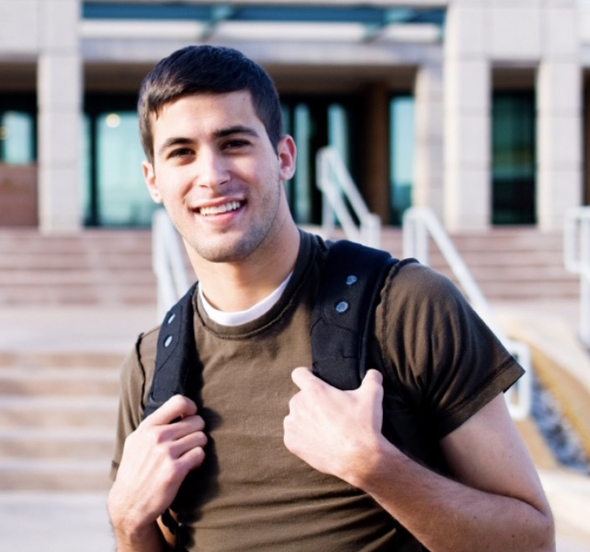

Caleb is a 20-year-old white male. He was raised as a conservative Jew in a suburban town. He is an only child that was raised in a tight knit family. His family maintains an average annual income of around $170,000.

He is in his third year at Syracuse University. He has become familiar with college life and so far, has had a great experience at the university. Caleb is a member of Zeta Beta Tau, a traditionally Jewish fraternity on campus. He is outgoing and enjoys hanging out with his fraternity brothers.

As Jacob gets more involved in his fraternity and has become program director, he is looking for ways to get his fraternity brothers involved. In addition to having events that are considered fun, he wants to plan events that help him and his brothers grow more in their faith and spirituality.

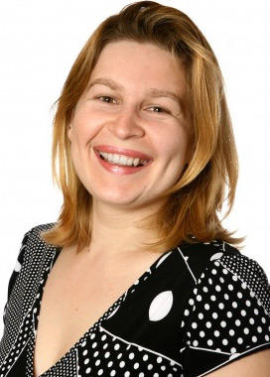
Rebecca is a white female in her late thirties. She received her bachelor’s degree in communications from LeMoyne College. She is originally from Rochester, New York, but currently lives in Baldwinsville, New York, with her husband and two sons. She enjoys activities such as going to the New York State Fair with her family and going apple picking during the fall.

She has worked in the administrative office at Hendricks Chapel for the past nine years. Her annual income is around $55,000. One of her favorite parts of the job is interacting with the students who visit the chapel.

Rebecca tries to attend most of the events that are hosted by the chapel but is unable to. She attends a local church with her family every Sunday. She has been attending that church for the past 12 years but has not gotten very active in the church due to her schedule at work.

Jamie is a 23-year-old graduate student at Syracuse University. She is originally from the Bronx, New York. She is still heavily dependent on her parents but is working toward financial freedom. Her parents make an annual income of about $150,000 whereas she only has an annual income of $30,000.

She completed her undergraduate education in New Jersey in psychology and is now receiving her master’s degree in higher education. She hopes to use her knowledge to bring education reforms in urban schools.

Jamie spends her free time hanging out with her colleagues in her cohort. As a child, she was extremely religious, but strayed away from religion when she first started college because she is questioning her belief in organized religion.

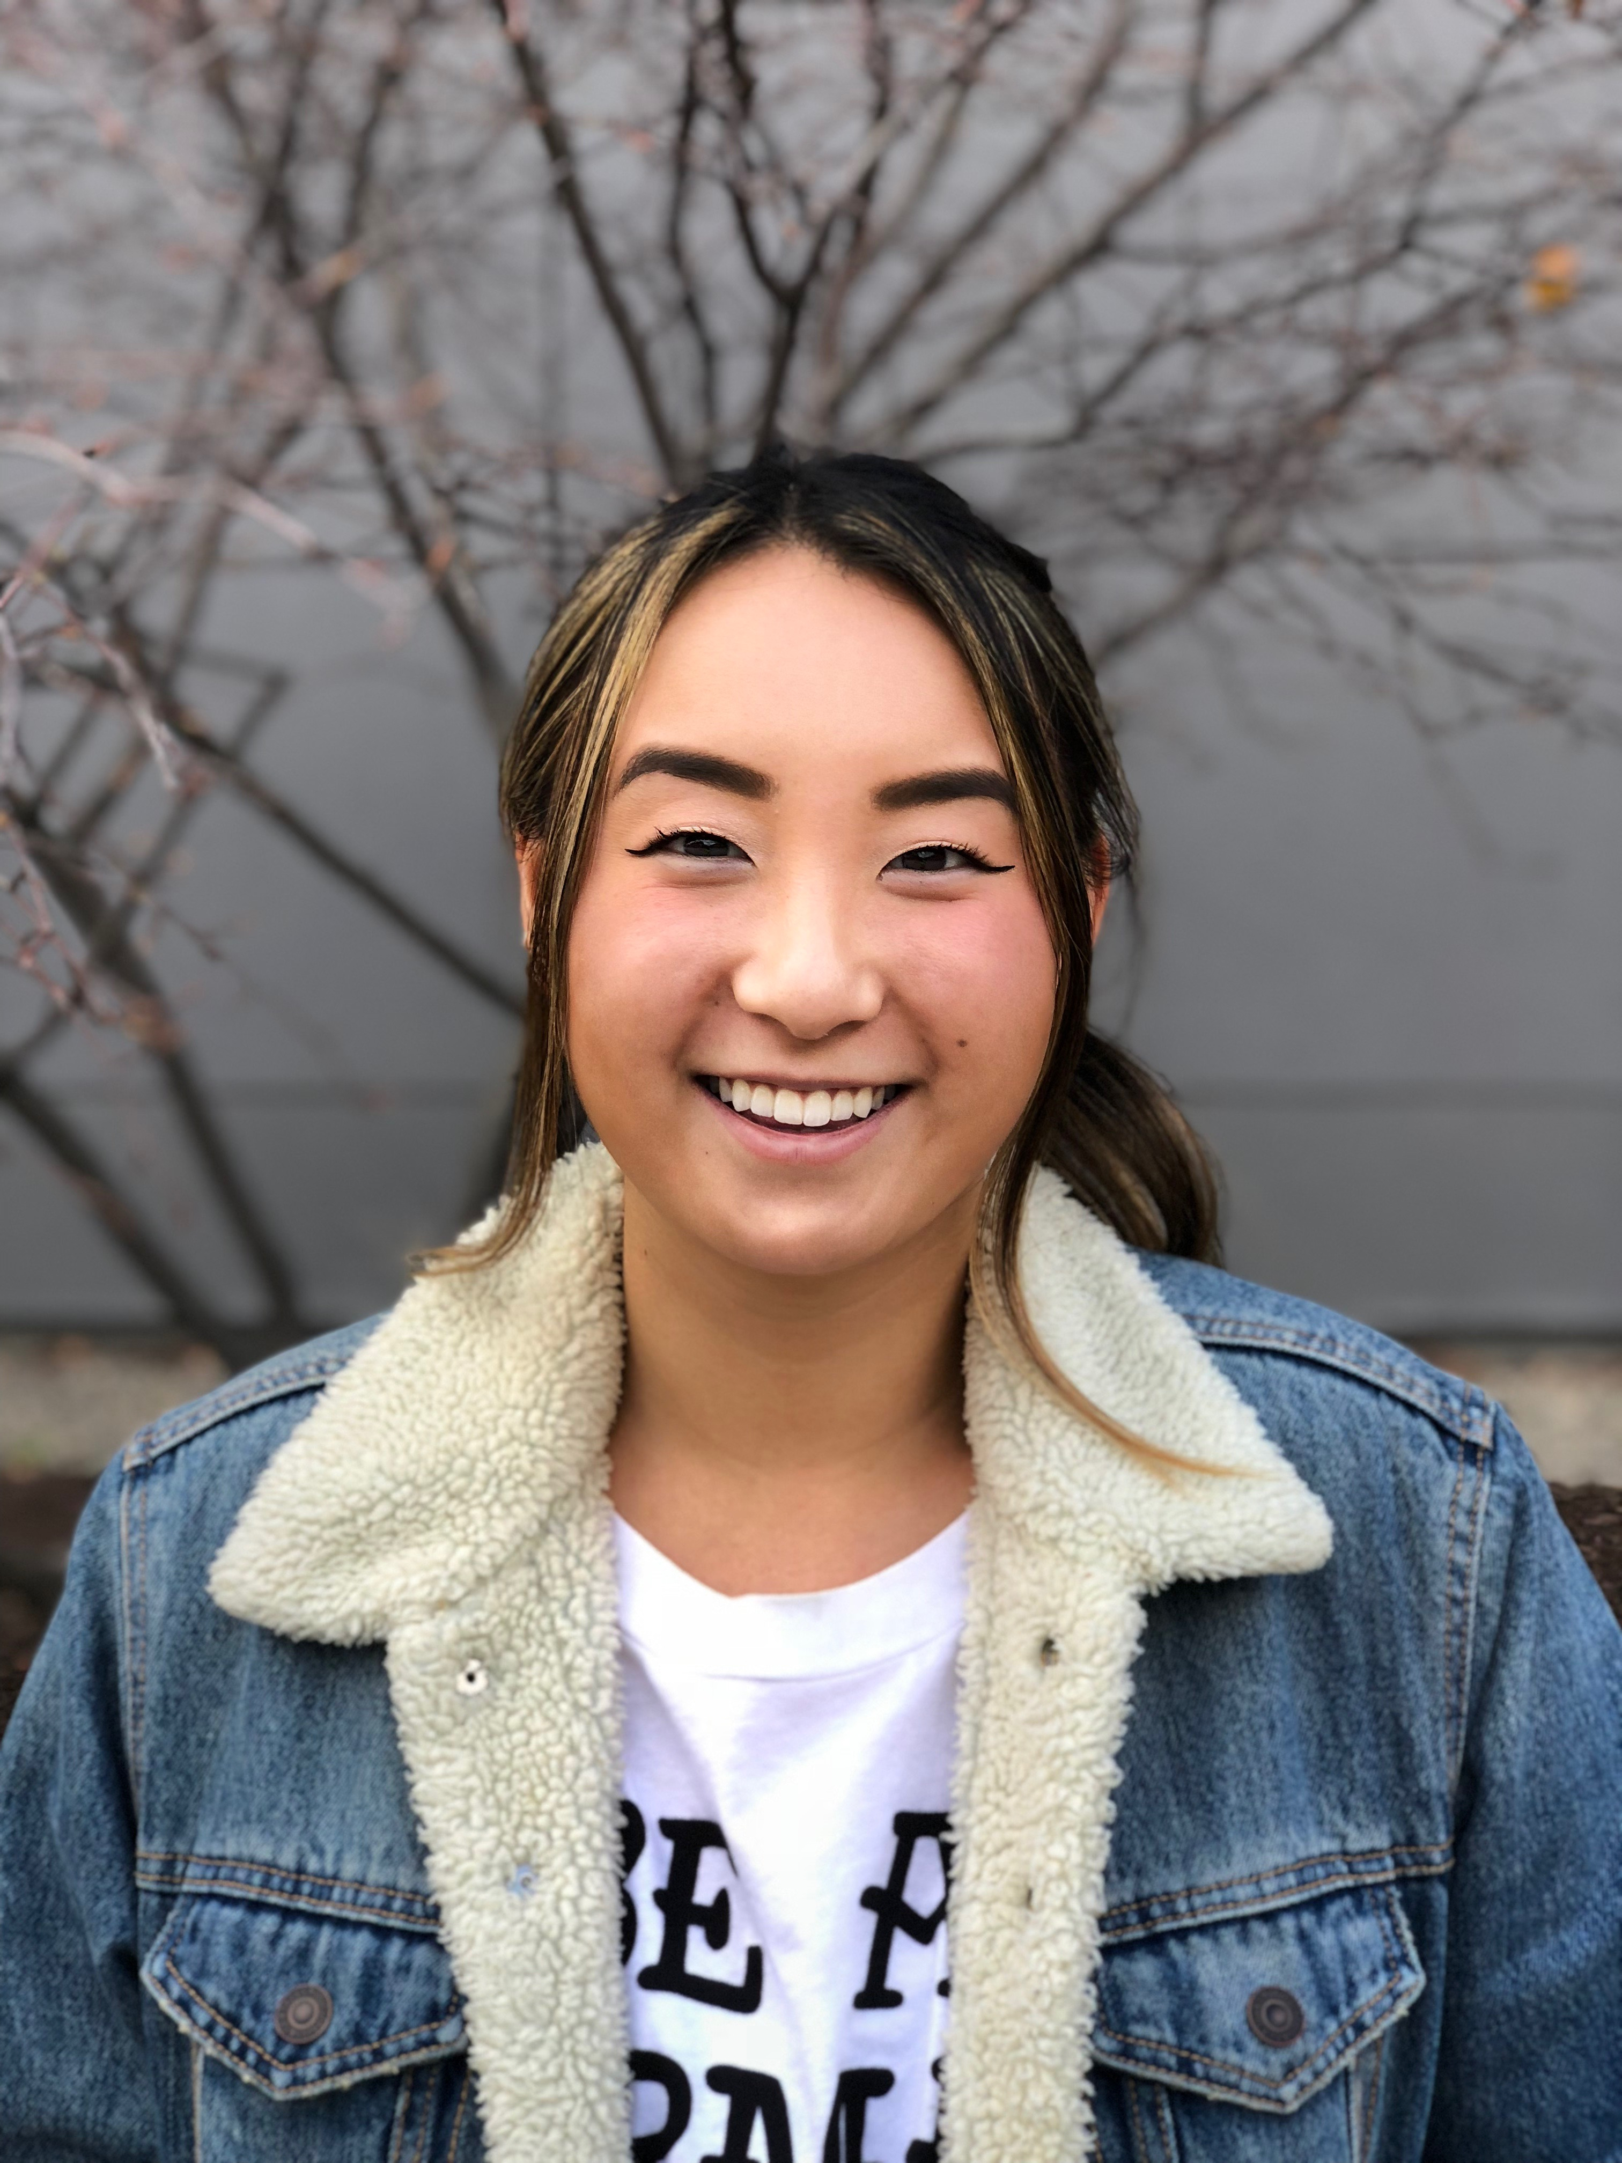
Seo-yeon Fang is a 22-year-old student from Seoul, Korea. She prefers to go by the name Leah. She is in her third year at Syracuse University. Although she enjoys being in the United States, she misses her hometown, especially the Korean food.

Leah is the only child in her family, her parents have an annual income of about $195,000. She is fond of traveling and has been to more than 5 countries including the United States. She enjoys seeing different cultures, food and lifestyles.

Leah spends her spare time with her roommates and others friends that are also originally from China. She likes to cook for her friends on the weekend. She has not given much thought to religion and spirituality.

Research Objectives

- Gain insight regarding the sentiments of how the community and the students perceive Hendricks Chapel.
- Evaluate the perceptions that community members and students have of the services Hendricks Chapel provides.

Research Methodology

To meet the research objectives, we used both qualitative and quantitative research. Social listening was used to analyze the community and student sentiments of Hendricks Chapel. This technique would fall under quantitative research. An online survey was created to analyze the perceptions of the key publics. This method would also fall under quantitative research. Finally, focus groups will be used to get a more in-depth view of our key public’s perception of Hendricks Chapel. This method is qualitative research. 4PR believes that the methods utilized will yield the most beneficial results to meet our client’s needs.

Research Method 1: Social Listening Analysis (Meltwater)

Sampling Frame: All social media posts were generated using Meltwater’s search feature, utilizing the key phrase: “Hendricks Chapel” between July 1, 2017, and Oct. 1, 2017. Only posts relating to Hendricks Chapel in Syracuse were considered, as well as posts from actual people as opposed to pages run by university offices or organizations were used in the social listening analysis.

Rationale: In order to best guide recommendations, we had to first understand what its key audience is talking about in regard to Hendricks Chapel on social media. By doing this we are able to evaluate how both students and the surrounding community perceive Hendricks Chapel, gaining insight to who specifically and what topics people are speaking about in regard to the chapel.

Execution:

- Recruiting Method: None
- Location: Online (Meltwater)
- Length: 10 minutes analyzing each social media post
- Incentive: None
- Number of Social Media Posts: 15

Data Analysis Method: Meltwater Widget Analysis

Research Method 2: Social Listening Content Analysis

Sampling Frame: The social media posts dated July 1, 2017, to Oct. 1, 2017, were selected using the Meltwater platform. These posts are mainly from individuals and represent public perception regarding the Hendricks Chapel and its services at Syracuse University.

Rationale: To help the Hendricks Chapel address its visibility issues in the public domain, our group chose these posts using the keyword “Hendricks Chapel” on meltwater, to gain a deeper understanding of the public sentiment toward the Chapel and its services. By analyzing these posts, we found out about the various chapel services that people are currently using. The analysis also offered insights regarding public behavior toward the chapel. For example, certain individuals were excited to use these services and invited others to join in while others were merely reporting what was happening at the chapel on that day. Through the analysis, we also found out about the opportunities that the Hendricks Chapel is providing for individuals to engage in community activities.

Execution:

- Recruiting method: None
- Location: Online (Meltwater)
- Length: 15 minutes analyzing each post
- Incentive: None
- Number of Social Media Posts: 15
- Data Analysis Method: Content analysis
- Posts: Appendix

Research Method 3: Online Survey
Sampling Frame: The sampling frame for the online survey includes first year female undergraduate students, male undergraduate-graduating students, international students and graduate students at Syracuse University.
Rationale for Sampling Frame: In the meeting with Dean Konkol, he mentioned the above publics are the target audiences for the Hendricks Chapel. In addition, typically, first year undergraduates and international students can stand for people who are curious and have limited knowledge on the Hendricks Chapel, by having them fill out the survey, we can understand how the potential audiences perceive the Hendricks Chapel and its statement, and what kind of programs they expect. Responses from undergraduate graduating students and graduate students can help Hendricks Chapel gain insights of how they assess the services Hendricks Chapel provided.

Execution:
- Recruiting Method: Post links to Facebook groups of target students in Syracuse University
Location: Online
- Length: five to 10 minutes
- Incentive: None
- Number of Participants: Our goal is to get minimum 100 responses
- Data Analysis Method: Qualtrics Data Analysis

Research Method 4: Focus Group
Sampling Frame: The sampling frame of the focus group included: first-year undergraduate female students, international students and graduate students.

Rationale: The focus group helped gain insights into how the different target audiences perceive Hendricks Chapel and their general attitude toward spirituality. By asking open-ended questions, students could give feedback to help provide suggestions regarding the most effective approach to increase the visibility of Hendricks Chapel. Furthermore, students provided clear insights regarding their current view of Hendricks Chapel and how that role can be enhanced to match with students’ expectations and needs.

Recruiting Method: Posted the focus group information on different social media, and invite potential participants with one-to-one personal conversation.
- Location: Newhouse III, 463
- Length: 60 minutes
- Incentive: Pizza and drinks
- Number of Participants: 12

Data Analysis Method: Content Analysis

Research Results and Analysis

Social Listening Analysis 1: Meltwater Widget Analysis

Media Exposure

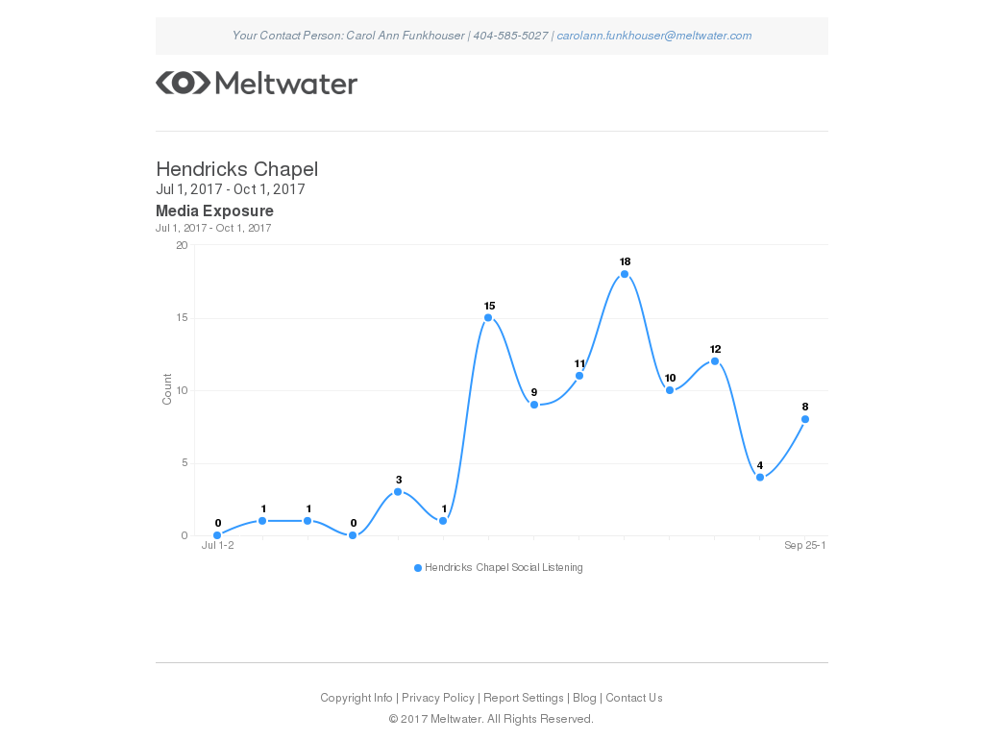

We can see from the media exposure widget analysis that Hendricks Chapel maintains a pretty positive trend in media exposure, with spikes surrounded large topics, typically having to do with the larger Syracuse University that Hendricks Chapel is involved in.

Top Sources

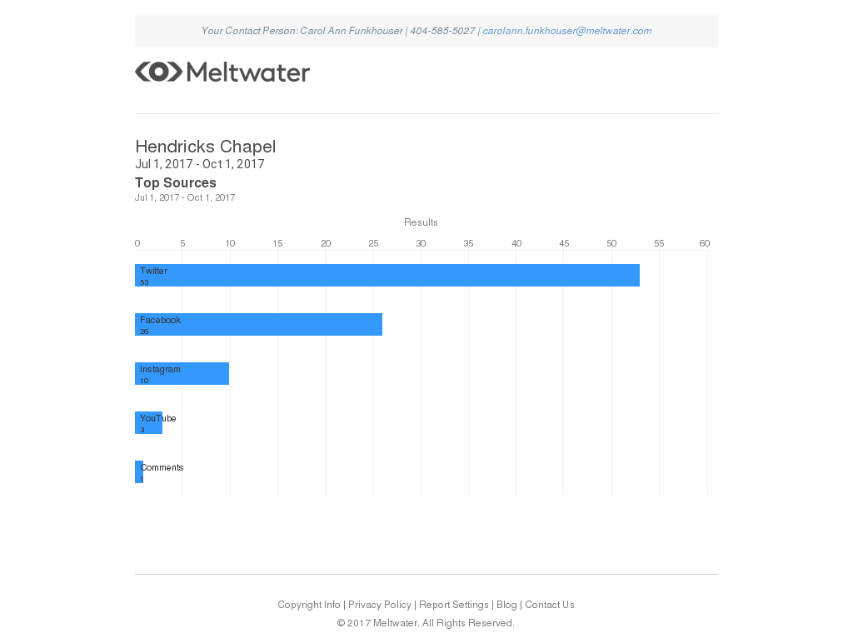

As we can see on the Top Sources graph from Meltwater, Twitter is the most widely used social media that Hendricks Chapel gets traction on.

Top Posters – Twitter

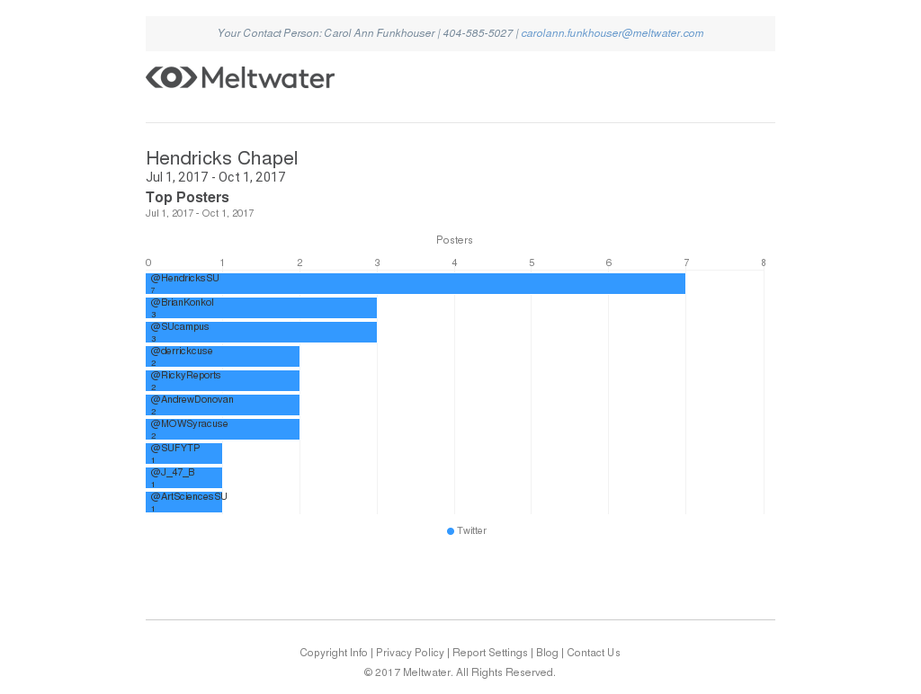

The top posters on Twitter for Hendricks Chapel are: the chapels Twitter account, Dean Konkol, SU Campus, Derrick Coleman (Syracuse/Maxwell Alumni), Ricky Reports Sayer (Current SU Student ‘21) and Andrew Donovan (WSYR reporter).

Topic Momentum

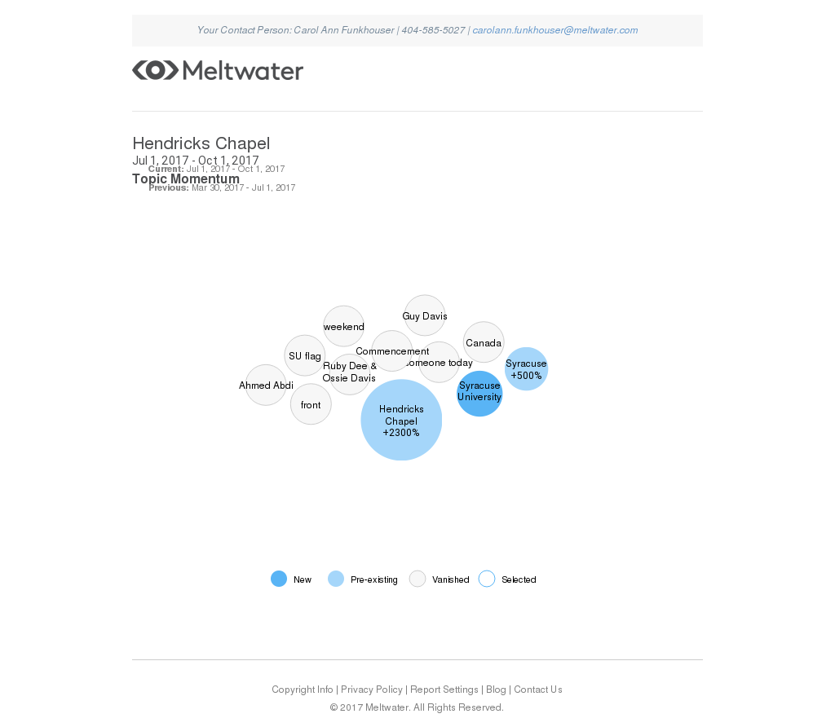

The Top Momentum widget gives us insight into some of the key phrases and terms that appear most commonly with tweets about Hendricks Chapel. They can assist us in digging deeper to figure out what conversations on social media are revolving around the chapel, sometimes not necessarily including or talking about Hendricks Chapel directly.

Social Listening Analysis 2: Content Analysis

Out of the 15 sample posts, 60 percent of them are on Twitter, and the remaining posted on YouTube and Instagram. The keyword for the posts was “Hendricks Chapel.” Considering the age demographic, 33.3 percent of them are aged below 30, approximately 53 percent are aged from 30 to 45 and only one person is older than 45. Considering gender, 66.7 percent of them are male, 26.6 percent are female and there is one organization. As far as location is concerned, 14 were in Syracuse when they posted the information, and three are living out of Syracuse – one in Buffalo, one in Liverpool and one in Bristol.

None of the posts are negative. Statistically, 53.3 percent of posts are positive, and the remaining are neutral. Considering time distribution, multiple posts were published on the same day but were spread out overall. Among the selected posts, 10 are considered relevant, as they reflect either the spirit of chapel or how the users assess the services; while three are controversial, as they just happened to mention the name of Hendricks Chapel; the other two posts have limited relations with the Hendrick Chapel and our research objective.

In terms of the external resources the these posts, nine posts use photos about Hendricks Chapel interior or exterior and all of them are positive pictures; while two added external links to positive contents; and one post on YouTube used a positive video. Overall, most have used external resources to support their posts and all of them are positive.

Research Method 3: Online Survey

Survey Questionnaire

Link : https://syracuseuniversity.qualtrics.com/jfe/form/SV_6XbtYnhecguamYB

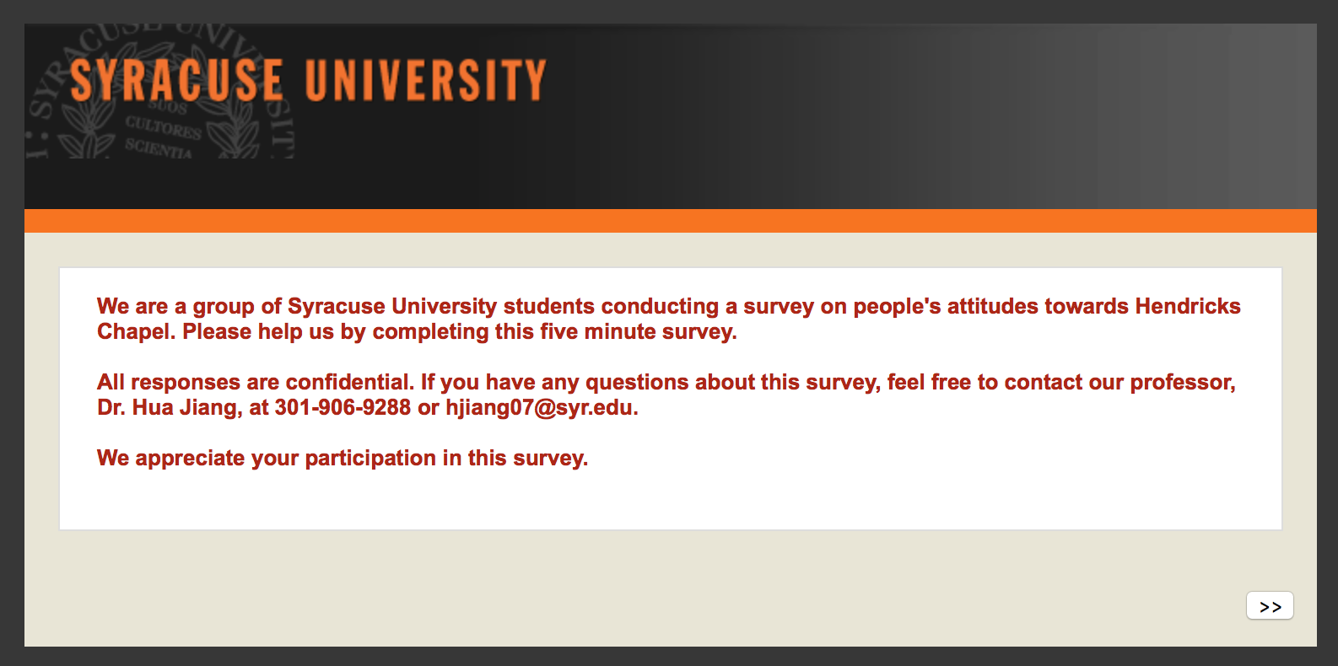
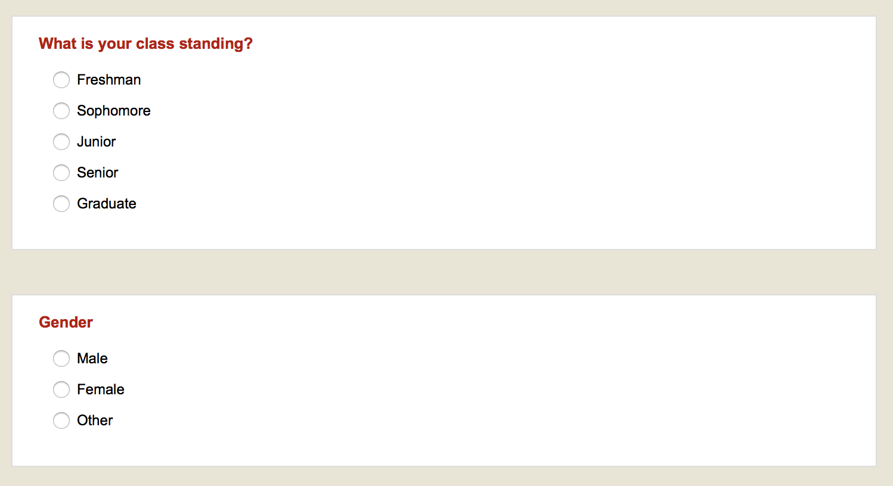
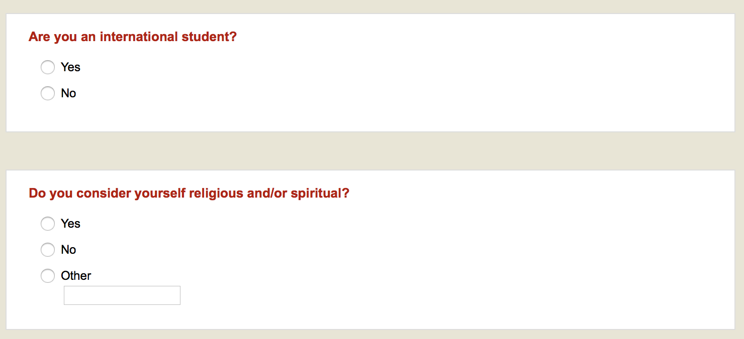
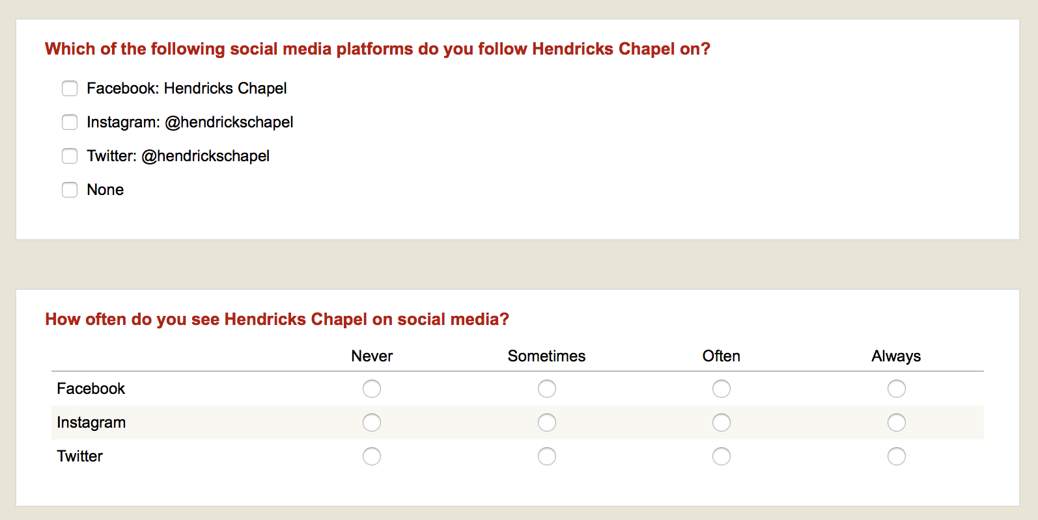
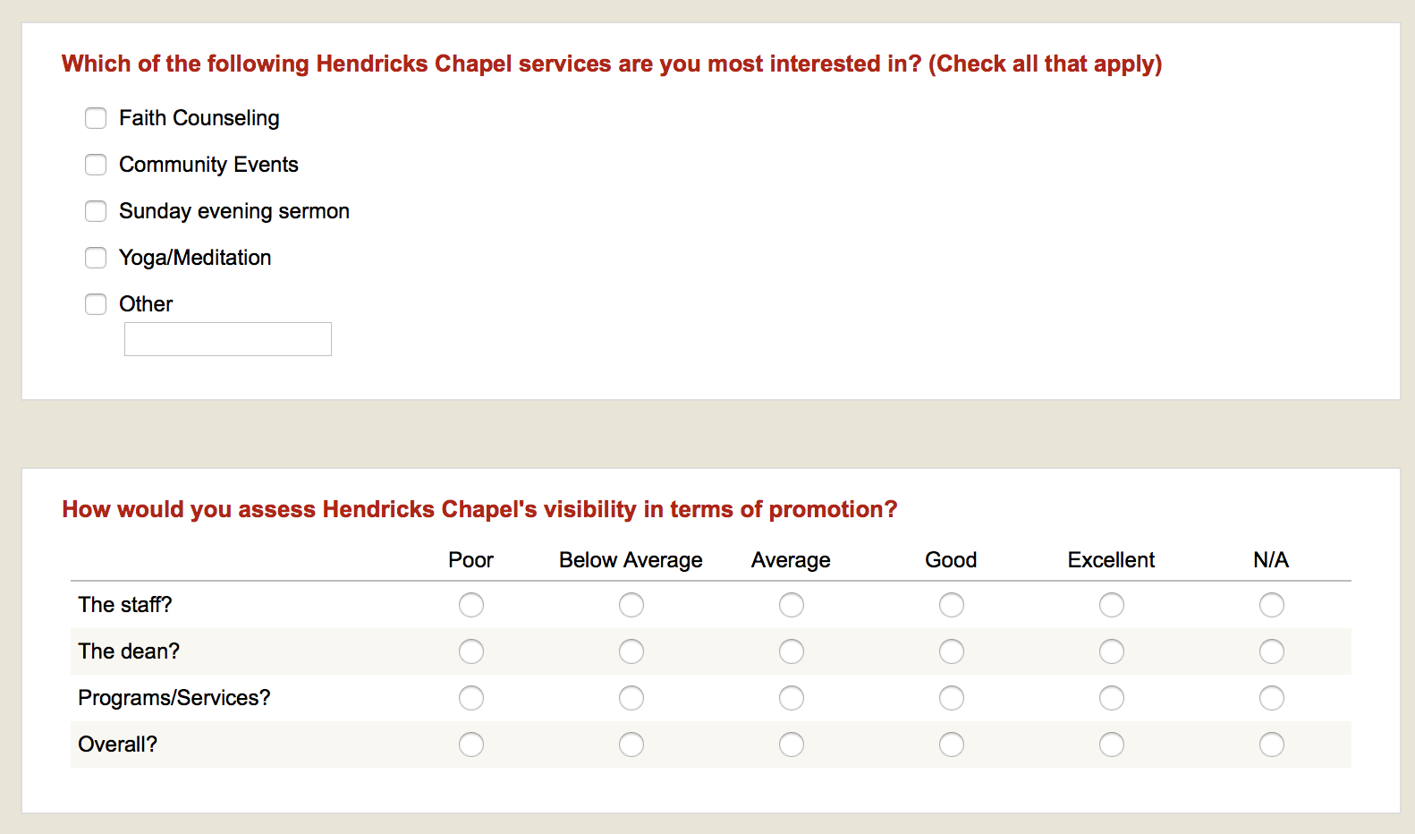
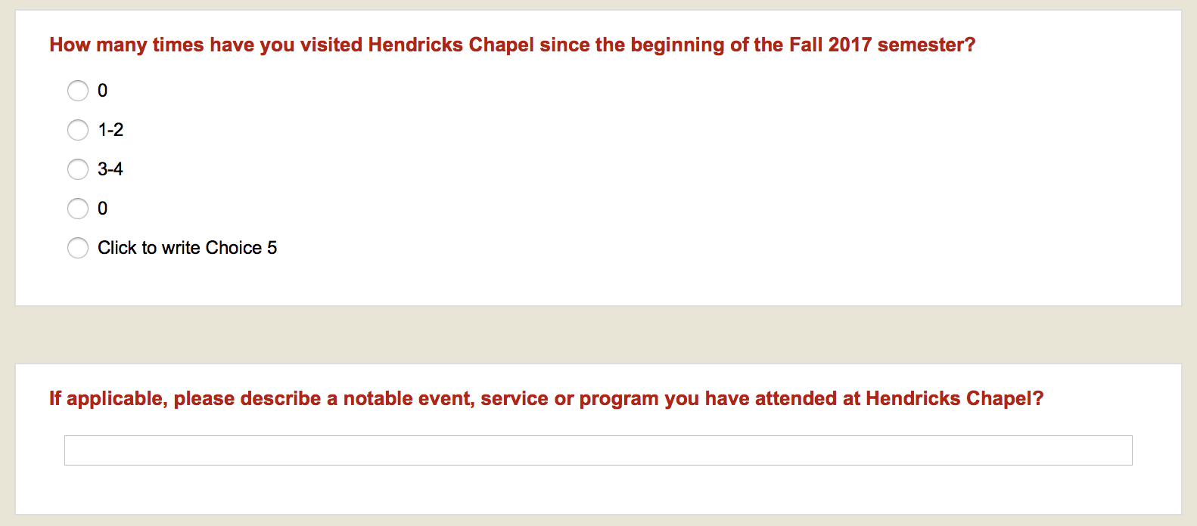
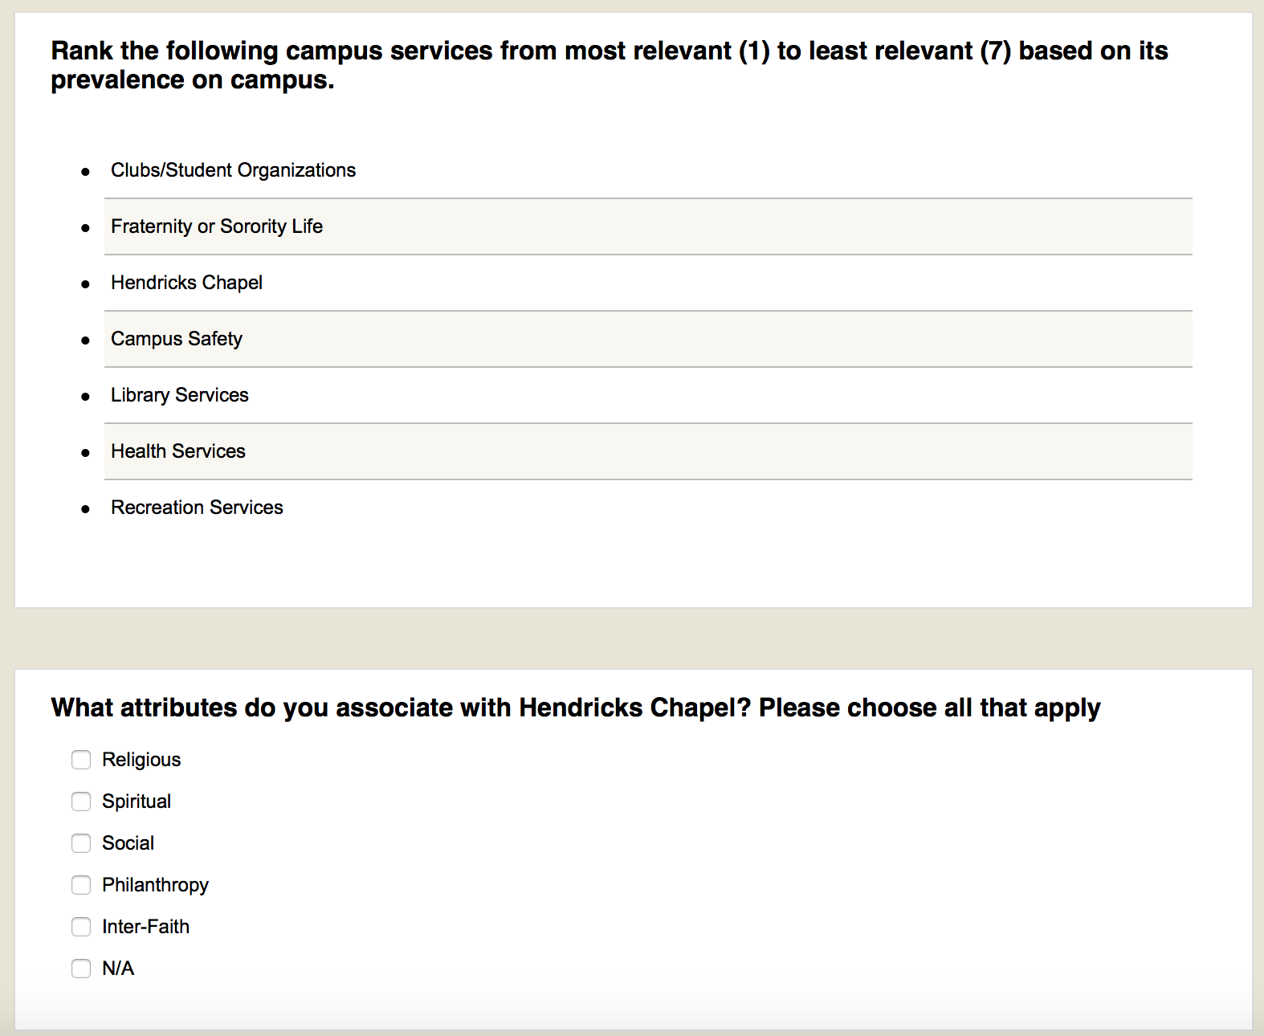
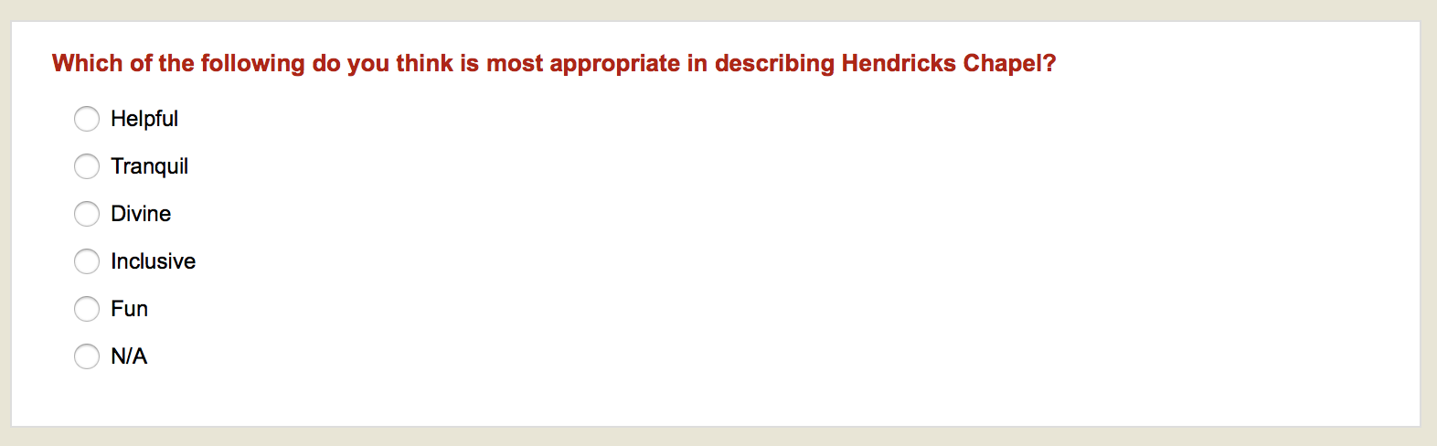

Survey Analysis

The survey aimed to measure the sentiments of the perceptions that the community and students at Syracuse University have toward Hendricks Chapel. There was a specific focus put on the perception of the services offered by the chapel. The main finding is that many students are aware of what Hendricks Chapel is, but do not necessarily know what services are offered due to a lack of direct marketing. Most of the survey respondents were females, domestic students and graduate students or community members. The majority of the survey respondents considered themselves religious or spiritual, however 40 percent don’t consider themselves spiritual or religious.

Other Explanations:
  - Semi-religious, not much spiritual
  - I grew up always with a spiritual outlook on the world that didn't really fit under any faith system that I was aware of. I ended up attending Catholic school from kindergarten all the way to grade school and high school, so I am very familiar with the Roman Catholic faith, and chose to be baptized and confirmed Roman Catholic by my own free will in elementary school. However, my time in Catholic high school changed my viewpoint on the religion, so I am at the point where I still have spiritual convictions but I do not fully identify with Catholicism anymore, and am currently trying to find a faith or spirituality that I better identify with. Thus, I currently am leaning more toward Buddhism and Taoism, but I have yet to decide what I choose to identify as anymore.
  - Sometimes

Survey Summary 1

To understand the sentiments of the community and students regarding their perception of Hendricks Chapel, the survey first measured if the respondents followed any of the social media accounts. Most the survey respondents did not follow Hendricks Chapel on any social media platform. Only five respondents were following on Facebook and two on both Instagram and Twitter. When asked the question, how often do you see Hendricks Chapel on social media? The majority reported that they have not seen the chapel on their social media feeds but if they were to find Hendricks Chapel on social media, Facebook was the medium in which Hendricks Chapel occasionally appeared on their feeds.

 | Never | Sometimes | Often | Always | Total
Facebook | 48 | 22 | 4 | 0 | 74
Instagram | 63 | 5 | 1 | 1 | 70
Twitter | 64 | 5 | 0 | 0 | 69

When participants were asked specifically about what services they were most interested in, community events were the most popular choice (36), followed by the Sunday evening sermon (14), faith counseling (9) and yoga/meditation (5).

Overall, students and community members are aware that Hendricks Chapel is at the heart of campus, but lack the knowledge of what services the chapel offers that could better serve them. The social media accounts currently being run by Hendricks Chapel are not reaching vast audiences. It would be beneficial to create a comprehensive plan that allows them to more effectively reach their key publics.

Survey Summary 2

Community members and students were asked to assess the visibility of Hendricks Chapel in terms of promotion. This question was used to further analyze perceptions that students and community members had regarding the services that Hendricks Chapel offers.

This question yielded insightful results as it relates to the different aspects of Hendricks Chapel. The perception of that staff is mostly below average at 25 percent and average being 29 percent. Dean Brian Konkol received majority positive responses with about 33 percent of survey respondents ranking his visibility as “good.” Most survey respondents generally had a positive view on the services and events held at Hendricks Chapel with rankings primarily in “average” and “good.” Overall, assessments of Hendricks Chapel’s visibility fall between the ranges of “below average” and “good,” with a slight positive skew toward good.

Survey respondents identified special events and ceremonies (11) held at Hendricks Chapel to have the most positive associations. Next in rank is the various lecture series (5) held at Hendricks Chapel. Other events that were mentioned include weddings (3), religious services (3) and meditation sessions (4).

Based on the results of this question, community members and students have an overall average view when it comes to the visibility of different aspects of Hendricks Chapel. Key publics especially resonate with Hendricks Chapel as it relates to it being a venue for other events. However, few survey respondents utilize the services and events that are hosted by Hendricks Chapel.

Focus Group Results and Analysis

Focus Group Summary 1: Most students have a general understanding about the chapel events through email communications, but lack the interest and buy in to read those emails.

The participants mentioned that they receive regular emails from Hendricks Chapel and are aware that different events are being hosted. However, focus group participants reiterated that most of those emails go unread, as the general student inbox is bombarded with clutter. Students are only interested in reading emails which are critically important to them and need their immediate attention. Students generally pay attention to communications that are strictly related to their coursework and assignments.

Focus Group Summary 2: Social media, traditional billboards and posters are effective when it comes to grabbing student attention

Students are unaware that Hendricks Chapel maintains a Twitter feed. These same students expressed their willingness to follow the account if the chapel has an interesting Twitter page that uploads videos and other engaging content of activities and events that are conducted by the chapel. Undergraduate students find Snapchat to be the most popular social media application among their peers. They suggested Hendricks Chapel have a presence on Snapchat. If the chapel cannot have an individual Snapchat account, it would be helpful if it can push content on it through the Syracuse story posted by students. The undergraduate students gave examples of student organizations using Snapchat to promote events and the effectiveness of this medium. Undergraduate students will be engaged through short and informative video segments.

The focus group participants expressed their enthusiasm with giant billboard, describing them as “eye-catching.” They explained that they can’t help but read the content on it, when passing by them across campus. They also shared that posters on bulletin boards are an effective advertising method when it comes to disseminating information about various events. One student gave an example of three successive posters that advertised the movie, “The Room.” The poster included movie reviews and were placed strategically so that the message was reinforced in the minds of the reader. They agreed that if Hendricks Chapel utilized advertisements that drew students in, it would cause

Additional Observations
Students appreciate the services of the chapel such as religious counseling, meditation classes and student choir performances. However, when it comes to attending these activities in real time, they are unwilling to because they don’t feel like the chapel can contribute to their campus life experience. Students also mentioned that the time of events conflict with their class and work schedule. Though this trend was visible more amongst graduate students, even undergraduate students had not attended any such activities and gave an unenthusiastic response when asked whether they will attend the same in the future. Many also recalled that the only time they heard about the chapel was through construction update emails in the beginning of the 2017 fall semester.

Recommendations

Snapchat. In order to engage with students where they are communicating, we suggest that Hendricks Chapel creates a presence on Snapchat. There are multiple ways Hendricks Chapel can do this. The first, creating their own account and posting stories when events are happening, linking to information or just highlighting the beauty of the chapel. Guests can be interviewed or filmed for a comprehensive approach to engaging with students. The second, create filters surrounding events so when students in the area go to send a Snapchat and are going through the geo-filters, Hendricks Chapel has one that comes up. The third, create a geo-story that allows students and community members to submit photos within a certain distance that all within that area can view on Snapchat. By integrating these three features of Snapchat, Hendricks Chapel will raise their visibility and be noticed by an audience they are targeting directly.

Snapchat Story Geo Story Snapchat Filters

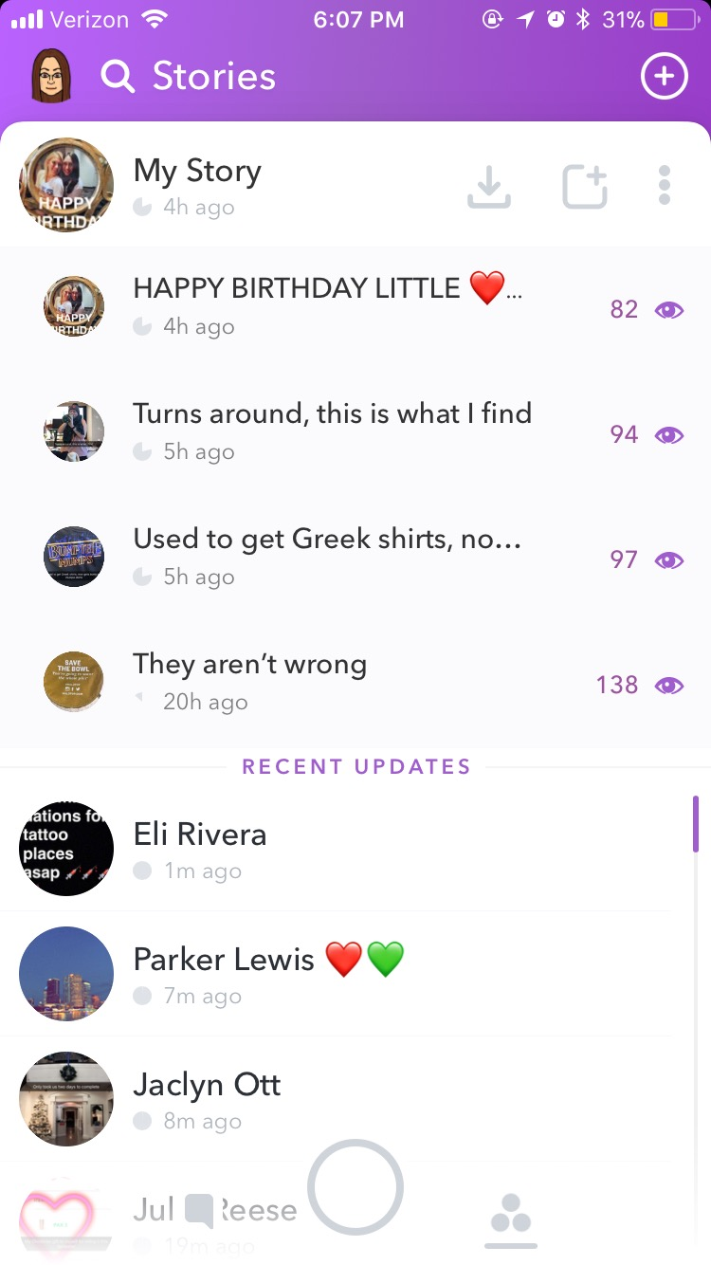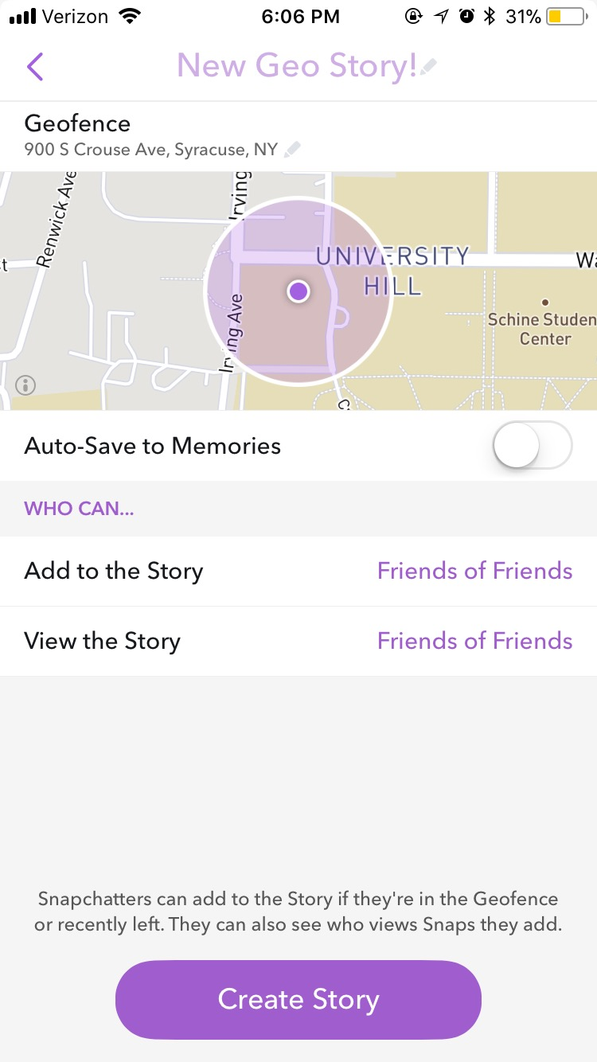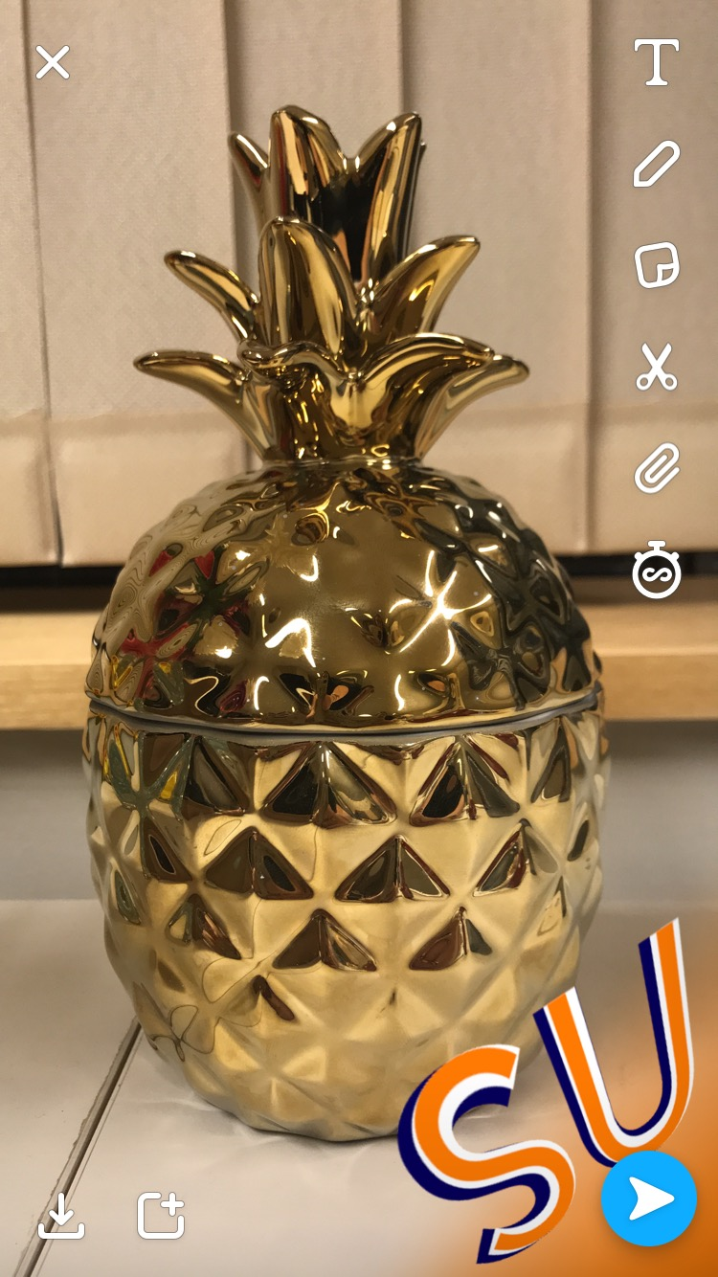

Blog. After collecting and making sense of data collected through primary, secondary, focus group and survey research methods, the 4PR team suggests Hendricks Chapel to initiate a weekly blog on faith, religion and spirituality in the context of student life on campus. The irrelevance of existing chapel services to the student life has been a repeating data pattern that has been observed during secondary research methods and focus groups. A dedicated blog that discusses students’ experience with spirituality, faith and religion and how it affects their life on campus will make the chapels presence on campus more relevant because it will provide practiced solutions to common as well as specific student problems. By interviewing and sharing experiences of students, the chapel can create a platform where students can engage with one another and with the chapel to find answers to questions that cause anxiety and stress in their lives. Through authentic student stories, students can relate better with the chapel and its purpose on campus. The blog can be a great medium of providing meaningful internship opportunities to Syracuse University students from specific departments. Talented journalism students can find an outlet and practice and hone their skills through the blog. The chapel can become more visible with the use of a blog coupled with the social media analytics and search engine optimization.

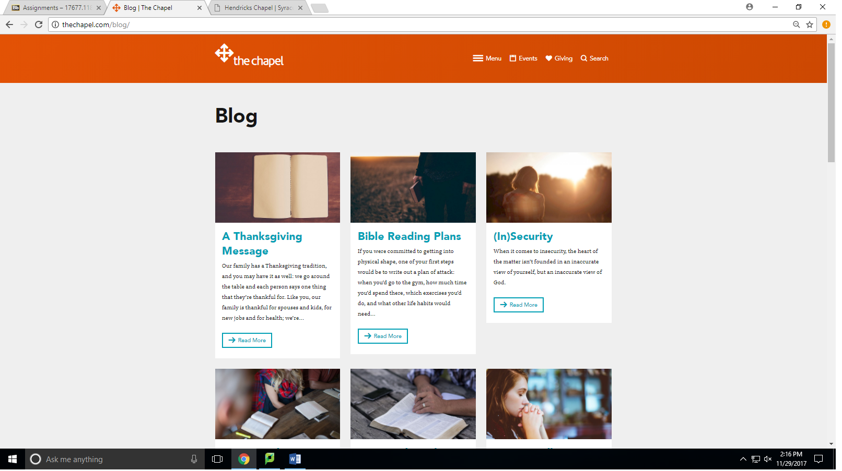

Staff Engagement with Students. After an analysis of the responses from the online questionnaire, students have mostly positive sentiments regarding the dean of
Hendricks Chapel, but this is not the same when it comes to other staff at Hendricks Chapel. This can be due to lack of interaction from other staff members a part of the chapel. It would be beneficial if the chapel staff increased their levels of engagement and interaction with students who not only visit the chapel, but with students who attend the university. Doing this will help increase positive sentiments regarding Hendricks Chapel.

Virtual Tour. Based on the Meltwater widget analysis and content analysis, Hendricks Chapel’s media exposure is relatively inconsistent and low, but what is out there highlights the beauty of the Chapel. Our research found that most the social media posts constructed were done so outside of the target audience. It was also revealed through the focus group that students find Hendricks Chapel beautiful and want a way to learn more about the Chapel and services it offers in an accessible way.

By hosting a virtual tour of the Chapel, highlighting different unique architectural components of the building itself as well as where specifically different services are offered, students are able to access information about the Chapel they wouldn’t be exposed to otherwise. By leveraging this tour through social media channels, a wide audience would be able to experience the Chapel and learn more about the services it offers.

References

Booth, K., Cooper, D., Karandjeff, K., Purnell, R., Schiorring, E., & Willett,
T. (January, 2013). What students say they need to succeed: Key themes from a
study of student support. Retrieved from https://eric.ed.gov/?id=ED548258

Brabham, D. C. (2008). Crowdsourcing as a model for problem solving. Convergence, 14(1),
75-90. doi:10.1177/1354856507084420

Cragun, R. T., Henry, P., Mann, M., & Russell Krebs, S. (2014). Chapel use on college and
university campuses. Journal of College and Character, 15(2), 103-118. doi:10.1515/jcc
2014-0014

Collaborating with Other Student Organizations. (n.a. & n.d.). Retrieved from
http://activeminds.org/storage/documents/Handbook_new/collaborating_with_other_stu
Ent_organizations_2014.pdf.

Dean of Hendricks Chapel, The Rev. Brian E. Konkol, Ph.D. (2017, September 13). Client
Meeting. S.I. Newhouse School of Public Communications, Newhouse 3 Room 463,
Syracuse, NY.

Lun, M. W. A. (2015). A qualitative study of students' perception of spirituality and religion.
Social Work and Christianity, 42(2), 178.

McCann, K. (2008). AASM college students involved in extracurricular activities are
likely to have sleep deprivation. Retrieved from
https://aasm.org/college-students-involved-in-extracurricular-activities-are-more-likely-t
-have-sleep-deprivation/

Pascarella, E. T., & Terenzini, P. T. (1991). How college affects students: Findings and insights
from 20 years of research. San Francisco: Jossey-Bass.

Stroup, A. R. (2017). Syracuse University International Slutzker Center for
International Services Total Enrollment. Retrieved from
https://www.census.gov/quickfacts/fact/table/syracusecitynewyork/PST045216

Stewart, T. J., M.S., Swift, J. K., Ph.D.., Freitas-Murrell, B., & Whipple, Jason L,Ph.D..,
A.B.M.P. (2013). Preferences for mental health treatment options among Alaska Native
college students. American Indian and Alaska Native Mental Health Research (Online),
20(3), 59-78. Retrieved from
https://search-proquest
com.libezproxy2.syr.edu/docview/1477572091?accountid=14214

Syracuse University. (2017a). Hendricks Chapel Chaplaincies. Retrieved from
http://hendricks.syr.edu/spiritual-life/chaplaincies.html

Syracuse University. (2017b). Hendricks Chapel Chapel Calendar. Retrieved from
http://hendricks.syr.edu/Events/calendar.html#/?i=7

Syracuse University. (2017c). Hendricks Chapel Staff. Retrieved from
http://hendricks.syr.edu/About%20us/staff.html

Syracuse University. (2016). Quick Facts Syracuse by the numbers. Retrieved from
https://www.syracuse.edu/about/history/quick-facts/

Syracuse University. (2017d). Spiritual Life. Retrieved from
http://hendricks.syr.edu/spiritual-life/index.html

Syracuse University. (2017e) Student Organization Information. Retrieved from
http://studentactivities.syr.edu/student-organization-info/index.html

Strahota, H. (October 28, 2015). Seventy percentage of college students work while
enrolled, new Georgetown University research finds. Retrieved from
https://cew.georgetown.edu/wp-content/uploads/Press-release-WorkingLearners__FIN
L.pdf

Unruh, H. (2010, November). Effectively engaging faith-based volunteers: Maximizing benefits
for both nonprofits and volunteers. In Proceedings of NACSW Convention.

Hoffman, M. (2010, April 10). Social media with a strategy (presentation slides). Retrieved from https://www.slideshare.net/See3/social-media-with-a-strategy-nonprofits-and-religious-organizations

Appendix

